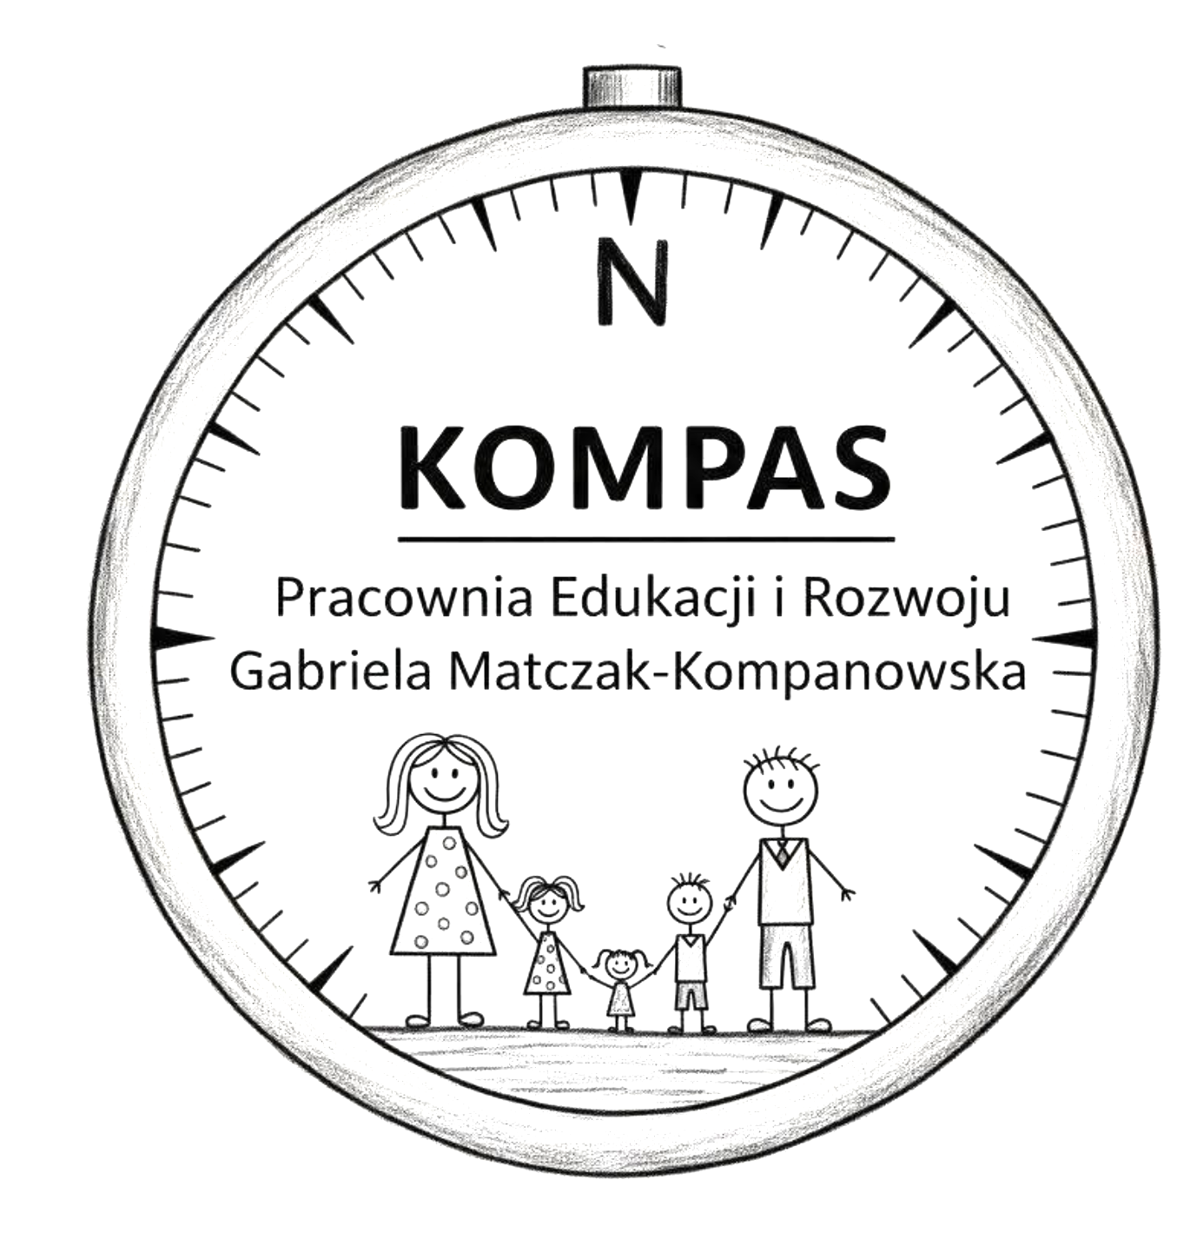

Harmonogram zajęć
„Od kreski do obrazu”

Numer zajęć | Miesiąc | Dzień
1 | X.2025 | 20.10
2 | X.2025 | 27.10
3 | XI.2025 | 3.11.
4 | XI.2025 | 17.11
5 | XI.2025 | 24.11
6 | XII.2025 | 1.12
7 | XII.2025 | 8.12
8 | XII.2025 | 15.12
9 | I.2026 | 12.01
10 | II.2026 | 2.02
11 | II.2026 | 9.02
12 | II.2026 | 16.02
13 | II.2026 | 23.02
14 | III.2026 | 2.03
15 | III.2026 | 9.03
16 | III.2026 | 16.03
17 | III.2026 | 23.03
18 | III.2026 | 30.03
19 | IV.2026 | 13.04
20 | IV.2026 | 20.04
21 | IV.2026 | 27.04
22 | V.2026 | 4.05
23 | V.2026 | 11.05
24 | V.2026 | 18.05
25 | V.2026 | 25.05
26 | VI.2026 | 1.06
27 | VI.2026 | 8.06
28 | VI.2026 | 15.06
29 | VI.2026 | 22.06
30 | VI.2026 | 29.06

